|  |  |  |
| --- | --- | --- |
|  | K. L. E. SOCIETY’S**K. L. E. INSTITUTE OF TECHNOLOGY,**Opp. Airport, Gokul, Hubballi-580 030Phone: 0836-2232681 Website: www.kleit.ac.in | **kle-logo** |

## **AICTE Activity Point Programme on**

**“Local Tourism Through Innovative Approaches”**

**Group Members Visited the Site**

|  |  |  |  |
| --- | --- | --- | --- |
| **Sl. No.** | **Site Name** | **USN** | **NAME** |
|  | GOKARNA | 2KE20CS007 | ANIRUDDHA S |
|  | 2KE20CS022 | DENZIL G R |
|  | 2KE20CS041 | M D SAQLAIN |
|  | 2KE20CS021 | DEEKSHA H PAWAR |
|  | 2KE20CS025 | GOURI G HIREMATH |
|  | 2KE20CS018 | BHAGYALAXMI BASAVARAJ KALLED |
|  | 2KE20CS010 | ANUSHA MADALLI |
|  | 2KE20CS015 | B M CHAITHRA |

**CHAPTER**

**GOKARNA**

* 1. **AIM**

Survey of the Gokarna town with its address and history.

**1.2 HISTORY**

Gokarna is a small temple town on the western coast of India in the Kumta taluk of Uttara Kannada district of the state of Karnataka,India.The main temple and deity is Shiva, who is also known as Mahabaleshwara. This temple houses what is believed to be original image of Shiva's linga (Atmalinga). There are many other temples all over this small town.

Ankola and Kumta on NH66 are the main towns where as Bhatkal and Karwar are the main small cities near Gokarna where almost all trains have halts and are connected to major cities like Chennai, Bangalore, Hyderabad, Mangalore and Mumbai through bus service.

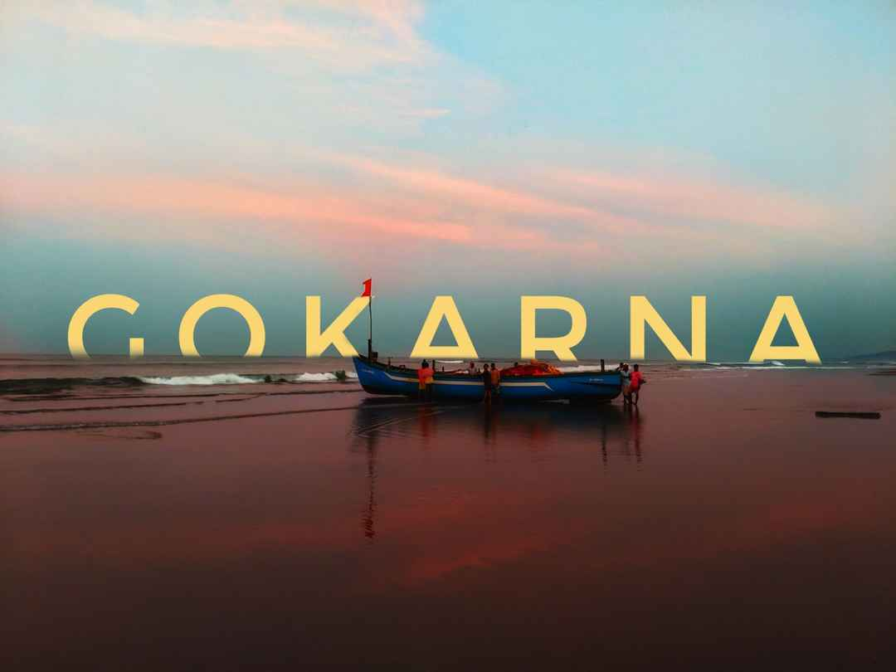

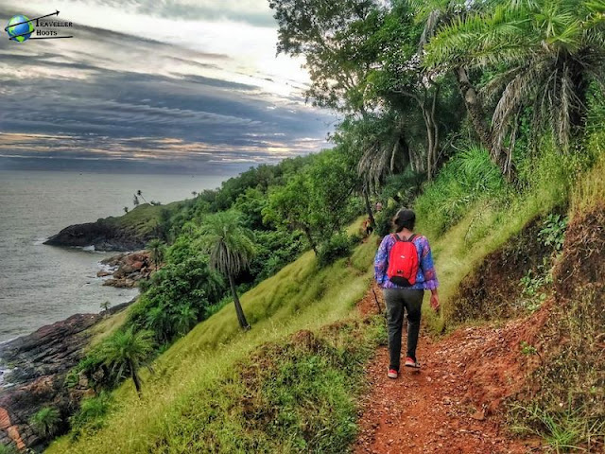

Gokarna means cow's ear. It is believed that Shiva emerged from the ear of a cow (Prithvi, the Mother Earth) here. It is at the ear-shaped confluence of two rivers Gangavali and Aghanashini. The Bhagavata Purana relates that 200 years into this current kali yuga a pious brahmana named Atmaveda was unable because of karma incurred in past lives to have any children in his current incarnation. Atmaveda was devastated by not being able to have children, and wandered into a forest to pray for help. There he met a Sannyasi, whom he implored to grant him and his wife the ability to have a child. The Sannyasi warned Atmaveda against opposing his karma, but finally relented and gave Atmaveda a fruit that his wife was to consume to have a child. Atmaveda's wife Dhundhuli didn’t want to go through the pain of pregnancy and childbirth, so she gave the fruit from the Sannyasi to her cow. A human child was born of the cow, human in all its parts except for its ears, which were cow ears. Because of this the child was named Gokarna.

Gokarna is mentioned in the Shrimad Bhagavata Purana as being the home of the brothers Gokarna and Dhundhakari. In order that Brahma who out of arrogance arising out of his power to create the universe, sat penancing to redeem himself from curse of Shiva, the latter appeared in front of him from the ears of a cow. So the place came to be known as Gokarna or ear of the cow. Hindu Puranas says that when Parashurama, the sixth avatar of Vishnu created Kerala, it was from Gokarna to Kanyakumari. As per legend, Ravana was given Atmalinga by Shiva and instructed that it would stay permanently where it is first placed on the land. But Ganesha came in the form of a boy and planted it in Gokarna while Ravana was performing rituals. Once placed Ravana could not remove it from the ground, but he removed some pieces of the Linga and threw them in different directions.

The earliest history of the city is in Treta Yuga, Ravana (Demon/Asura King of Lanka) reaches Kailasa and performed rigorous penance to get the "Atma Linga" from Shiva, as Ravana's mother expressed a keen desire to worship the atmalinga of Lord Shiva.After a long penance, Shiva gave the Atma linga to Ravana as a boon and instructs Ravana to carry it home by walk, that he should never place it on the earth even for a short while failing which the linga would get eternally embedded at the place where he broke his commands.

Maha Vishnu learned that Ravana will become all powerful by worshipping the 'Atma Linga' and menace to the world and Ravana's conviction that nobody could defeat him, once he acquired the very power of Shiva. Maha Vishnu devised a plan to install the linga somewhere and as he thought that Ganapati was alone capable of doing it, he along with all the gods pleads Ganapati to execute the plan. Ganapati accepts and reaches Gokarna as a Brahmin boy. As Ravana was nearing Gokarna, Maha Vishnu who had known well that Ravana was punctual in performing his periodical rites (Sandyavandhana), hides sun with his Sudarshana Chakra (Wheel). Thinking that it was time to perform the evening rites, Ravana finds a Brahmin boy and asked him to hold the Atmalinga in his hand till he came back after finishing the rites. Ganapati agreed to hold the linga on one condition that he would do so till he would be able to bear the weight of linga and that thereafter he would call Ravana three times and if failed to come to him by then he would place the linga on the earth.

Ganapati calls Ravana three times when he was performing his rites and places the linga on the earth and he vanishes. The Atmalinga at once got firmly entrenched in the earth. Ravana learned that he had been tricked by the Gods. The depressed demon king Ravana was deeply agitated and tried to pull up the linga, but the linga did not budge a little. It resulted in his throwing the coverings of the Linga to Dhareshwara, Gunavanteshwara, Murudeshwara and Shejjeshwar temples. Ravana was unable to lift the linga from the ground again and called the Shiva linga as Mahabala, one with great strength, and ever since, the linga illustrious as Mahabaleshwara.

Shiva learned all these from Vayu Deva, the god of wind, and came on to Earth with Goddess Parvathi devi and his train of Gods, he visited these five places and worshipped the linga which had now taken five forms. He acknowledged that these five places would be his "Pancha Kshetras" (Five Holy Places).

Gokarna was part of the Sodhe and Vijayanagar kingdoms. When the Konkan region — including Goa — was occupied by the Portuguese, it became part of their rule.

**1.3 MAP OF GOKARNA**

* **How to reach Gokarna by Air**

Travelers who are coming to Gokarna will find the nearest airport in Dabolim in Goa. This airport is around 140 kilometers away from Gokarna and you can hire a taxi to reach the destination. This airport is well linked with both domestic as well as international cities in UK and Germany also.

* **How to reach Gokarna by Rail**

Gokarna has its own rail link which is well connected with Margao. But not every train stops here. If you are coming to Gokarna via railways then the nearest railway station is located in Ankola which is about 20 kilometers away from the region. You can take a taxi or a bus to reach the final destination from outside the railway station.

* **How to reach Gokarna by Road**

You can reach Gokarna by direct buses from all the cities like Goa, Bangalore, Mangalore, Pune, Delhi etc. You can also hire a private cab or drive your own vehicle depending on your comfort and convenience.

* Distance from Karwar. 59 km
* Distance from Udupi. 178 km via NH66
* Distance from Mangalore. 231 km via NH66
* Distance from Ratnagiri. 383 km via NH66 or NH48
* Distance from Pune. 544 km via NH48
* Distance from Coimbatore. 656 km via NH69, NH48
* Distance from Kochi. 663 km via NH66 or NH69
* Distance from Mumbai. 682.9 km via NH 48
* Distance from Delhi. 2,024.9 km via Mumbai-Agra National Highway

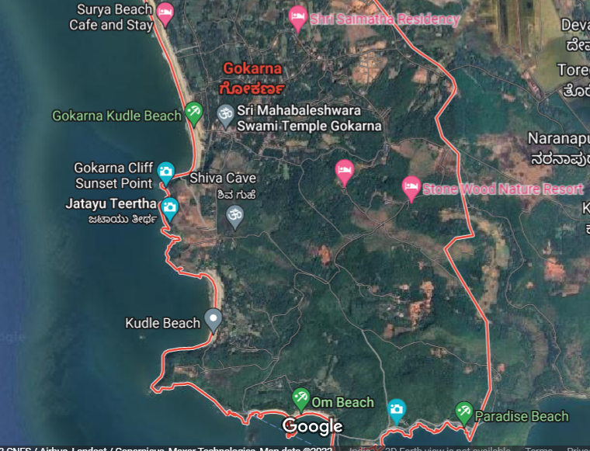

**1.4 Places to Visit and Things to Do in Gokarna**

* Sri Mahabaleshwar Temple
* Maha Ganapati Temple
* Gokarna Main Beach
* Om Beach
* Halfmoon Beach
* Paradise Beach
* Kudle Beach

**1.4.1 SRI MAHABALESHWAR TEMPLE**

The temple is one of the seven sacred Muktikshetras or Muktistala ("places of salvation") in Karnataka. It is a place where many Hindus of Karnataka perform obsequies (death rites) for their departed. The six other Muktikshetras in Karnataka are at Udupi, Kollur, Subrahmanya, Kumbasi, Koteshvara and Sankaranarayana.

According to legend, the Atmalinga was perforce placed at Gokarna, in the temple precincts where it is now deified. It was Ravana, the demon King of Lanka, known from the epic, Ravana had carried it there from Mount Kailash in the Himalayas.

This is one of the holiest site for shiva and finds its mention in several Puranas, Ramayana and the Mahabharata. The temple's first construction was by the king Mayurasharma of the Kadamba dynasty (reign 345 CE – 365 CE). Again, legend holds that Mayurasharma wished to learn of the Vedic rites and the Ashwamedha Yagna (ritual of horse sacrifice). He travelled to Kanchipuram, a major religious learning centre, but there, he was insulted by a horseman guard. He was angered and swore to defeat the ruling Pallava dynasty. Following his defeat of the Pallavas, the king asked some priests to perform a daily yajna to maintain his suzerainty over the region. Mayurasharma's son, King Kangavarma brought Brahmin families from different lineages to maintain administration at the temple.

The classical Sanskrit writer, Kalidasa mentions the "Lord of Gokarna" in his 4th century work, Raghuvamsha. The Gokarna temple is recorded as one of the Paadal Petra Sthalams in the 7th century Tevaram by Appar and Sambandar wrote canon of devotional poetry. The temple is a large complex of shrines and much of it belongs to the later Vijayanagara period (1336–1646 CE). A Vijayanagara emperor once visited the temple and weighed himself in gold. During the 17th century reign of Queen Chennammaji and her son, Soma Sekharanayaka of Keladi, Visvesvaraya of Halasunadu-Kundapura built the Chandrasala and Nandi pavilions. In 1665, the warrior king, Shivaji (1630 CE - 1680 CE) worshipped at the Mahabaleshwar temple after disbanding his army in Gokarna.

In 1676, Fryer, an English traveller, visited Gokarna during the Maha Shivaratri festival and wrote in detail about it at the temple.

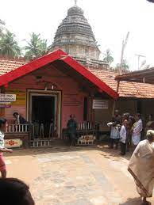

**1.4.2 MAHA GANAPATI TEMPLE**

According to Indian mythology, when Ravana, in his second attempt, was returning from Mount Kailasa to Lanka carrying the prized possession of an Atmalinga, his route crossed Gokarna. Ceasing the opportunity, the gods hatched a plot against Ravana as they did not want him to finish the journey. They sent Lord Ganesha, who took the avatar of a young monk to deceive Ravana and keep Atmalinga on the ground. As the condition was that wherever Atmalinga is lowered and kept on the ground first, that place shall become its final place of worship. For this feat of securing the Atmalinga in Gokarna (refer to Shree Venkataramana Temple for details), Lord Ganesha is worshipped first and foremost and people visit this temple before praying to the Atmalinga at the Mahabaleshwar Temple.At the entrance of the temple, situated in the middle of a road, you can spot a few barefooted Indian women selling flowers to earn their living. As you enter the precinct, a railing separates the queues of people going in and coming out. Temple bells swing carelessly overhead and its pealing sounds fill the premises. The statue of Lord Ganesha faces west towards the Indian Ocean. You are guided to walk around the idol and as you complete the pradakshina, a priest offers prasadam. This is relatively a small temple and, with a moving queue, you would be in and out in less than 10 minutes. Here's a tip: don’t forget to remove your socks too, as they’re considered part of footwear. The authorities here are strict about following procedures to the hilt.

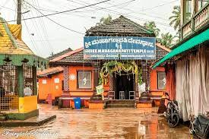

**1.4.3** **MAIN BEACH**

One of the most popular beaches in Gokarna, Gokarna Beach recently gained fame for being a surfing site. It is also famous for its scenic trekking excursion one can take from here.

Located in close proximity to the Mahabaleshwara Temple, the Gokarna Beach is also known as the place where pilgrims first come to take a dip before visiting the temple. You can also visit the other beaches of the region, like Half Moon Beach, Paradise Beach, Om Beach as well as Kudle Beach from here.

This beach gives off some of the most beautiful sights of the ocean and the surrounding hillocks. Some of the adventure activities you can engage in Gokarna Beach include surfing, jet skiing, snorkeling as well as trekking.

* Location: Gorkana Village | Ankola, Gokarna, India
* Best Time to visit: October to March.
* Activities and Watersports: Yoga, surfing, jet ski, banana boat, snorkeling,and trekking.
* 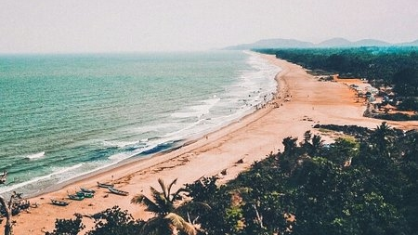Distance from Gokarna Bus Main Stand: Around a KM away.

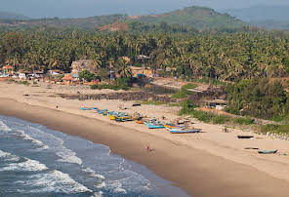

**1.4.4** **OM BEACH**

The beach is shaped in a way that it appears to be the auspicious symbol ‘OM’ in the Devanagari script and is named after it. Om beach is one of the pristine and happening beaches in Gokarna for the plethora of water sports and activities that people cherish here.

From the bumpy banana ride to the speedy jet ski ride, from beachside trekking on the hilly terrain to spotting Dolphin in the middle of the sea; OM beach is spot on.

The beach can be enjoyed between the two coves that make the shape of OM and is loaded with shacks, huts, and cafes for a lazy vacation.

* Location: Om Beach, Gokarna, Karnataka 581326
* Best Time to visit: November to March
* Activities and Water Sports: Jet ski, trekking, trekking, swimming.
* Distance from Gokarna Bus Main Stand: Around 6 KM.

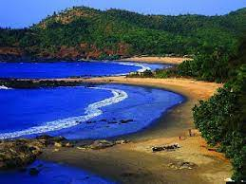

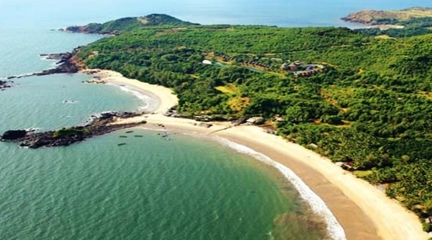

**1.4.5**  **HALFMOON BEACH**

Beaches are awesome but a thick and lush jungle overlooking an infinite stretch of Arabian Ocean is ecstatic. Half-moon beach is such an experience where you get to engage in myriads of activities like swimming, kayaking, paddle boats, trekking, camping, etc.

Half-moon is one of the beaches in Gokarna which you can also walk up to it in a scenic trek starting from Gokarna beach and cover the famous five Gokarna beaches in one go. This beach derives its name from the shape of it which resembles a half-moon.

* Location: Half Moon Beach, Gokarna, Karnataka 581326
* Best Time to visit: November to March.
* Activities and Water Sports: Swimming, kayaking, paddle boats, trekking.
* Distance from Gokarna Bus Main Stand: Approximately 5 KM.

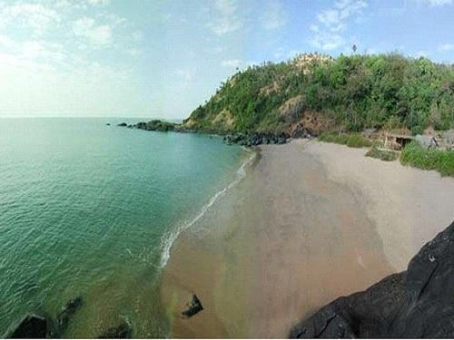

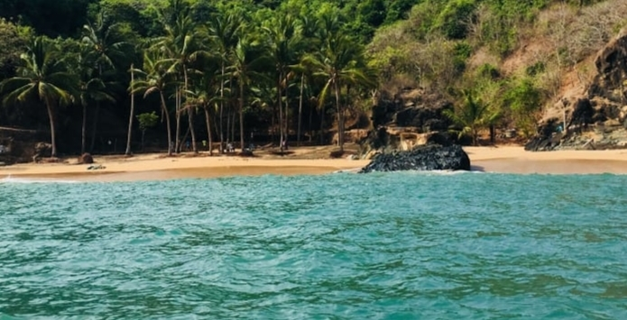

**1.4.6**  **PARADISE BEACH**

Fondly known as the ‘full moon beach,’ Paradise beach justifies its name. In order to reach this beach, one has to take a motorboat from OM beach or half-moon beach or has to trek down from the half-moon beach.

Paradise beach stretches around 150 meters in length and is an ideal destination for swimming and camping. Around 70 percent of the beach is covered in rocks which makes some picture-perfect elevation points for photography.

* Location: Gokarna, Karnataka, India
* Best Time to visit: Sunrise and sunset during the winter and spring season.
* Activities and Water Sports: Swimming and trekking.
* Distance from Gokarna Bus Main Stand: Around 8 KM, 20 minutes boat ride from OM beach.

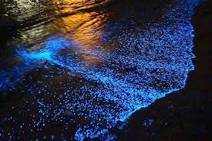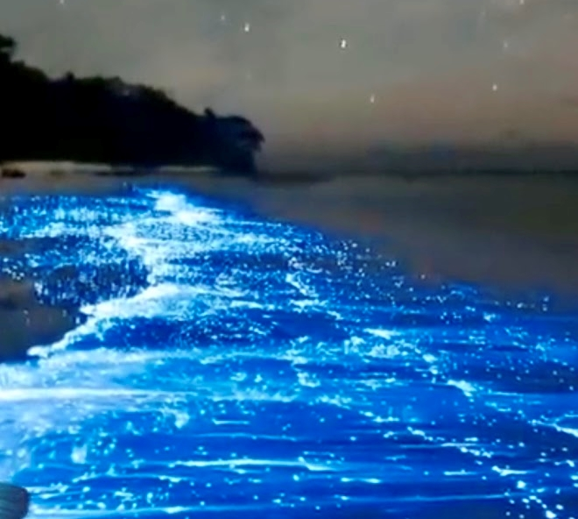

**1.4.7**  **KUDLE BEACH**

One of the really famous Gokarna Beaches is Kudle Beach. It is a long stretch of fine sand and blue sea which is quite isolated and is therefore perfect for those looking for solitude and serenity.

Located away from the busy touristy areas of Gokarna, Kudle Beach is mostly frequented by foreign travelers in search of solace and relaxation. Best known as the area for swimming and diving, Kudle Beach is situated very close to Om Beach as well as Gokarna Beach.

A blessing for nature enthusiasts, this beach is the best place to go to if you wish to spend some time alone, or with loved ones, while capturing the stunning sunsets and nature views.

* Location: Kudle Beach Rd, Gokarna, Karnataka 581326
* Best Time to visit: November to February is the peak season, however, the locals pitch up temporary huts, shacks, and other makeshift arrangements by the beach from October till March.
* Activities and Water Sports: one can swim in the seawater, trekking is another activity
* Distance from Gokarna Bus Main Stand: Approximately 6.5 KM.

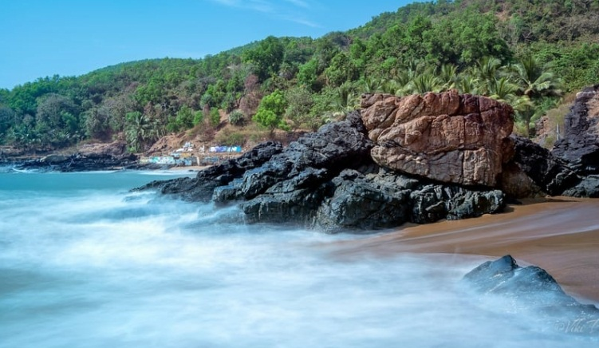

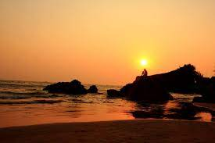

**FAQ’s related to Gokarna**

Q. Why is Gokarna famous?

Gokarna is famous for its very significant Mahabaleshwara Temple and breathtaking beaches that are untouched and less explored.

Q. What are the best things to do in Gokarna?

Being a beach destination, there are a plethora of thrilling water sports activities such as scuba diving, parasailing, jet skiing, snorkeling etc that keep the travelers entertained. Also, solace seekers and pilgrims like paying homage at the temples of Gokarna that are epitome of Dravidian architecture.

Q. Is Gokarna better than Goa?

If you are looking for a solace and laid back beach vacation then Gokarna would be a better option for you. Its serene environment and virgin beauty is detoxifying and relieves the travelers from all the stress of busy city life.

Q. Is Gokarna near Goa?

Gokarna is near to Goa as it is about 145 km away and takes barely 3 to 4 hours drive to reach this hidden gem of Karnataka via road. Also, the nearest airbase to Gokarna is in Goa.

**REFERENCES**

1. <https://www.holidify.com/places/gokarna/sightseeing-and-things-to-do.html>
2. <https://en.wikipedia.org/wiki/Gokarna,_Karnataka>
3. <https://www.adotrip.com/destination-detail/gokarna>
4. <https://www.trivago.in/en-IN/lm/hotels-gokarna-india?search=200-344928;dr-20220620-20220621>
5. From Instagram
6. From native people.
7. Visited the place.